  Date: 25th January 2021 |  |  |  | Theme: Wriggle and Crawl  Year group: 1/2
Literacy      This Photo by Unknown Author is licensed under CC BY-NC-ND   | Numeracy     | Creative     | Thinking     |  | Healthy me    
Weekly Spelling  Practice reading and writing the words on the spelling sheet. Look, cover, write, check each of the words.  Rising Stars  Read assigned book on the Rising stars website and complete questions on book.  Literacy  Watch the video again to remind you what happened.  https://www.literacyshed.com/butterflies.html  Read the description of what happened when the book opened.  Use the word mat and the sentence starter to write your own description. There are some useful words at the bottom of the page to help you.  Reading Comprehension  Read the information on Tom Wicks the Butterfly explorer and answer the questions.  Story Mountain    I would like you to think about writing your own story about a magical book. What animals could come out of the book - what would happen if lions and tigers came out of the book into the classroom? What would happen if fish came out? Use the story mountain to start planning your own story.  Welsh  Welsh –  Tric a Chlic – Listen to the story ‘yn y bath’.  Match the sentences to the pictures.  Focus  Mrs Moore would like to buy some new clothes. She would like a new set of clothes that she can wear during each of the different types of weather we have in Wales.  Write a shopping list of clothes she could wear using the sentence pattern:  Mrs Moore yn gwisgo …………………  Roleplay  Visit the shop. Choose a weather type and ask for the clothes to wear for that type of weather. Ask how much the clothes are?  Ga i ……… /Can I have?  Faint ydy’r ……….?/How much is……………?  Slot Drillio  Numbers Flashcards.  Click on the links to listen to songs about the weather/numbers:  Singing about the weather - BBC Bitesize  Counting 1 to 100 - BBC Bitesize  Choosing clothes - BBC Bitesize | My Maths  Counting in 5s  5 Times Table.  Click on the link to listen to the 5x table song:  5 Times Table Song | Skip Counting - Bing video  White Rose Maths.  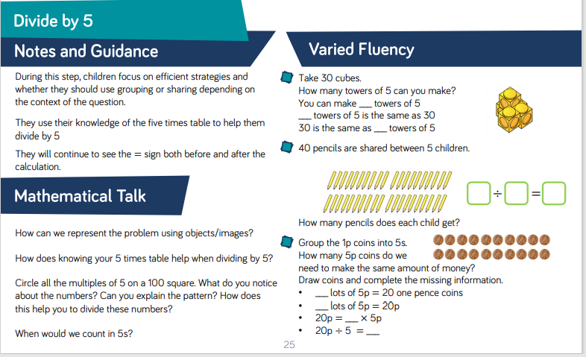  Shape  This week we are going to look at 2d/3d shapes.  Match the shapes to the names.  Go on a shape hunt around your house/garden and create a tally chart to show how many of the shapes you find.  ICT  Choose one of your tally charts and create a pictogram using J2 Data.  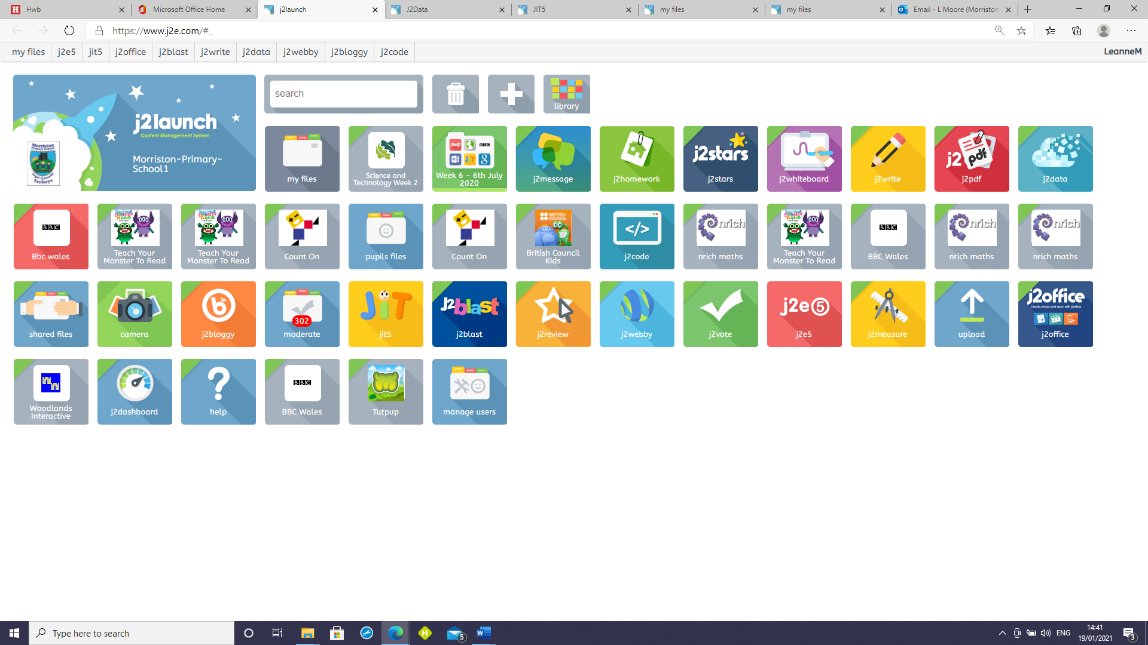  Click on J2 Chart:  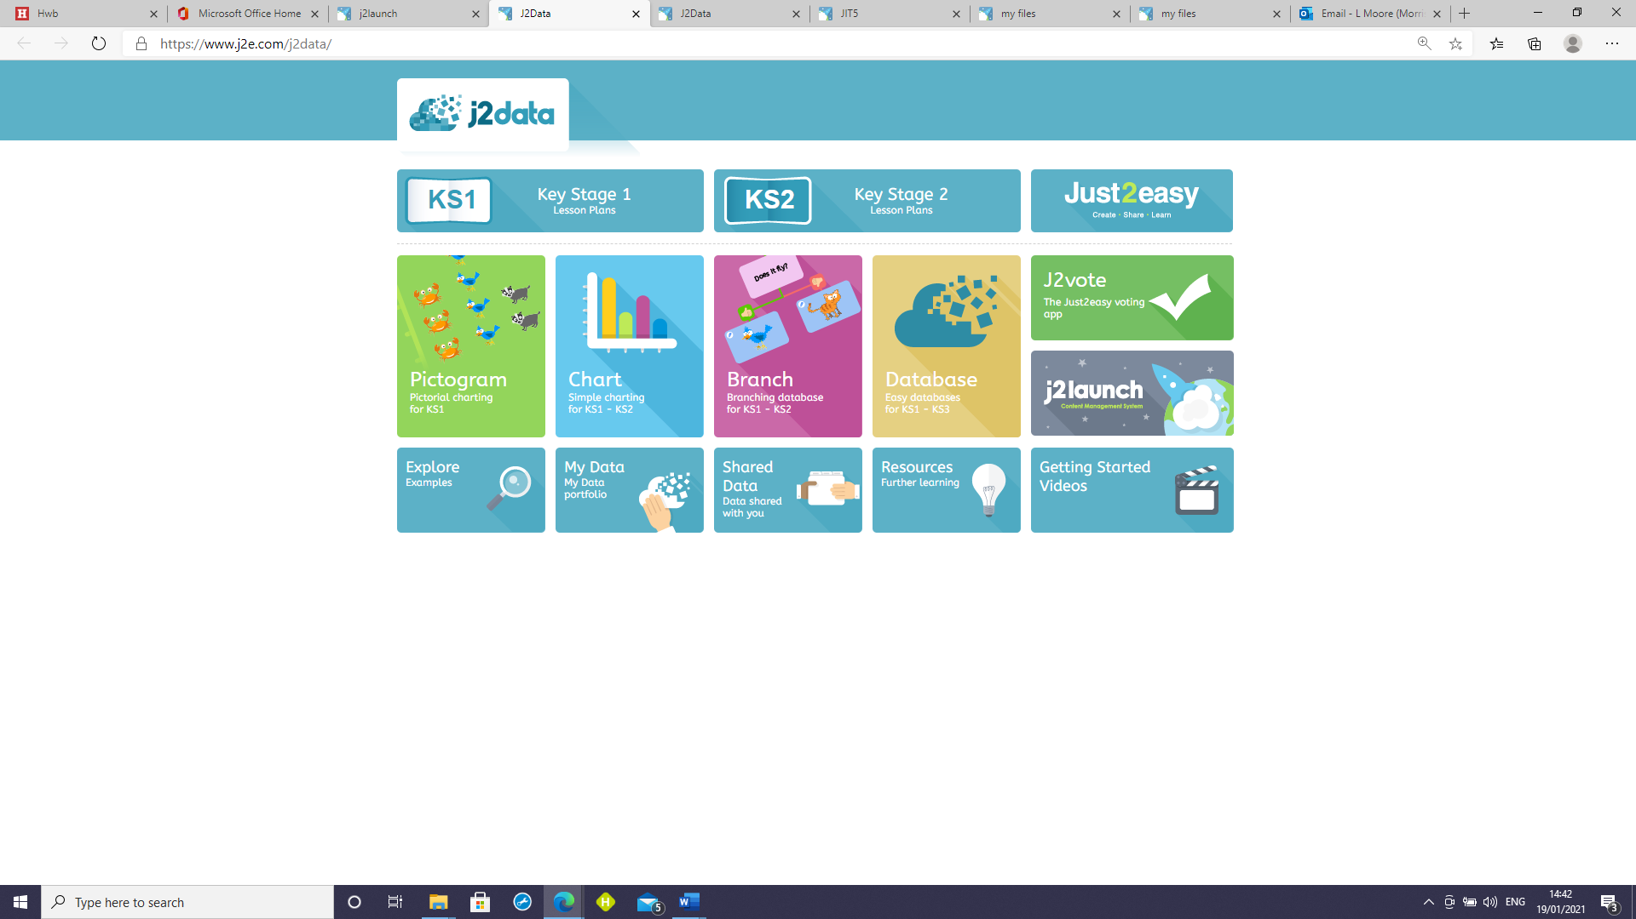 | Art Challenge  Create a flower pattern in sand, soil, shaving foam, flour, sugar, salt or talc.  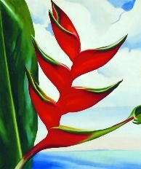  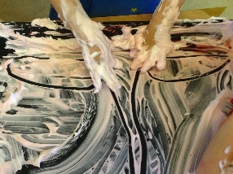  Click the link and watch the flower drawing video. Draw a flower whilst watching the video.  18: Kids' Tutorial - How to Draw a Flower (B) in 2 Minutes | Simple, Easy & Fun | Vivi Santoso - Bing video   | The Hungry Caterpillar  Listen to the story the hungry caterpillar.  Flipgrid Code for story  https://flipgrid.com/80b9408d  Life cycle of a Butterfly  Click on the link to watch the video about butterflies.  Complete the life cycle of the butterfly activity.  The Life Cycle Of A Butterfly - Bing video  ICT  Create an algorithm using J2code. Move the butterfly to each of the flowers.  Flow Charts  Mrs Moore has created and shared a flow chart asking questions about different types of Mini Beasts. Create your own flow chart using 4 different minibeasts.  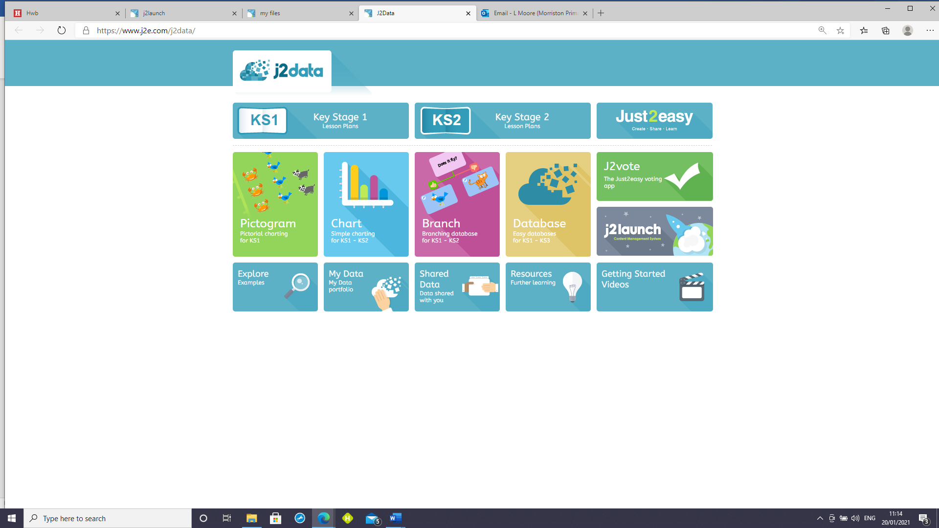   |  | The Messy Magpie  Read the story ‘The Messy Magpie’.  Write a rhyming poem on how to keep our community litter free.  The Bog Baby  Watch the Book flic on Flipgrid. Look at each of the pictures and record a flip grid response about what you think is happening in the story.  Flipgrid code  https://flipgrid.com/fcafc5dd  

