 | Look  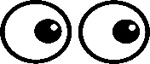  This Photo by Unknown Author is licensed under CC BY | Cover  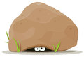 | Write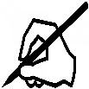 | Check  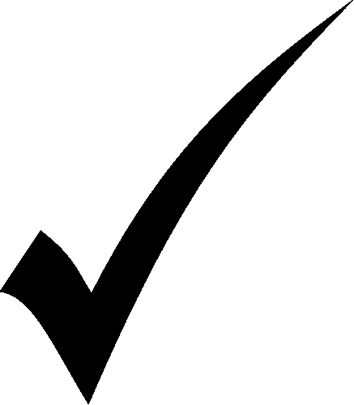  This Photo by Unknown Author is licensed under CC BY
stop
step
spin
spot
steep
creep
sheep
come
where
there

Learn these spellings. I will post a spelling quiz on Friday on HWB.
Choose 5 of the words and write a sentence using those words.

