  Date: 1st February 2021 |  |  |  | Theme: Wriggle and Crawl  Year group: 1/2
Literacy      This Photo by Unknown Author is licensed under CC BY-NC-ND   | Numeracy     | Creative     | Thinking     |  | Healthy me    
Weekly Spelling  Practice reading and writing the words on the spelling sheet. Look, cover, write, check each of the words.  Rising Stars  Read assigned book on the Rising stars website and complete questions on book.  Literacy  Watch the video again to remind you what happened.  https://www.literacyshed.com/butterflies.html  Writing your story  Use your story planner from last week to write your own story about the magical book.  Look at the story writing power point and checklist to find out all the important features that you will need to include to make your story successful.  Reading Comprehension  Read the information on mini beasts and answer the questions.  Handwriting  Copy the poem in your neatest handwriting. Remember to whoosh in and out and join your letters.  Welsh  Welsh –  Tric a Chlic – Listen to the story ‘Ben’.  Answer the questions using ydy or nag ydy.  Focus  Listen to the story ‘Tedi Tw ar y tywydd’.  Read the story independently.  Answer the questions on the story.  Slot Drillio  Learn the names of the minibeasts in Welsh and colour the pictures.  Find the Welsh minibeast names in the word search.  Click on the link to listen to the song about feelings:  Singing sweets - BBC Bitesize  Click on the link to find a lesson on minibeasts.  What are minibeasts? - BBC Bitesize  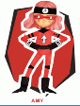 | My Maths  2D/3D shapes. Year ½ tasks to be completed by all children.  Click on the link to listen to the 5x table song:  5 Times Table Song | Skip Counting - Bing video  White Rose Maths.  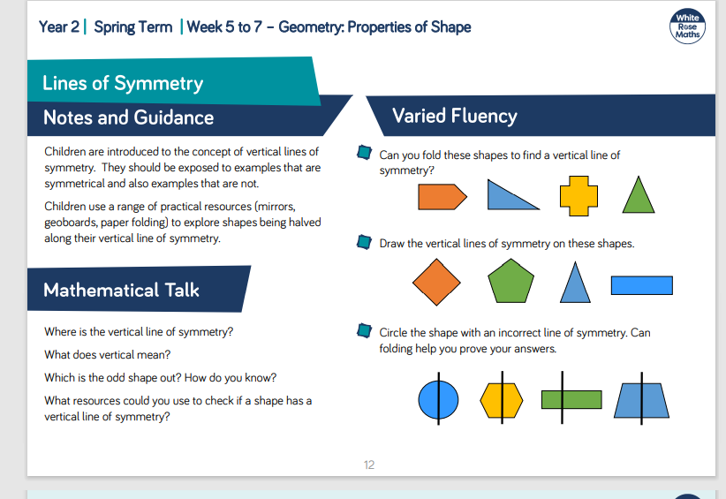  Symmetry  This week we are going to look at lines of symmetry.  Play the power point presentation all about Spectacular symmetry.  Draw 6 different 2d shapes. Draw the line of symmetry.  Complete the symmetry activity sheets.  J2 Blast  Practice your times tables using J2 Blast  Live Session – Thursday (1pm)  Recognising 2d and 3d shapes. | Art Challenge  Follow the instructions to make an origami heart.  Mrs Watts Art Challenge:  Ladybird Potato Stamps  Follow the instructions on the resource sheet, to make ladybird stamps from a potato. You can even turn them into hand-made cards for family and friends. Have fun!  Mrs Watts Music Challenge:  I Love Worms  Using the resource, 'I love Worms',  Make up your own rhyme or song for the verse.  Flipgrid Code:  https://flipgrid.com/ef9470a8  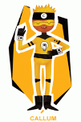 | Science Investigation  How do Germs spread?  Read the Background Information on Germs on J2E  THINK about what things you touch during the day. Think about all the activities you do that you need to use your hands.  Write a list of 15 things you touch with your hands during the day.  Add pictures of activities that you do with your hands using J2E. Mrs Moore has shared an example.  Look at a member of your family’s hands. Look really closely between their fingers, on their palms and around and under their nails. What can you see? What might be there that you can't see? Talk with a family member about the different ways to stay clean and stop germs spreading that you know.  Draw an observational drawing of their hand and label it.  Life cycle of a Butterfly  Click on the link to watch the video about butterflies.  The Life Cycle Of A Butterfly - Bing video  ICT  Create an animation using JIT 2 animate to show the life cycle of a butterfly.  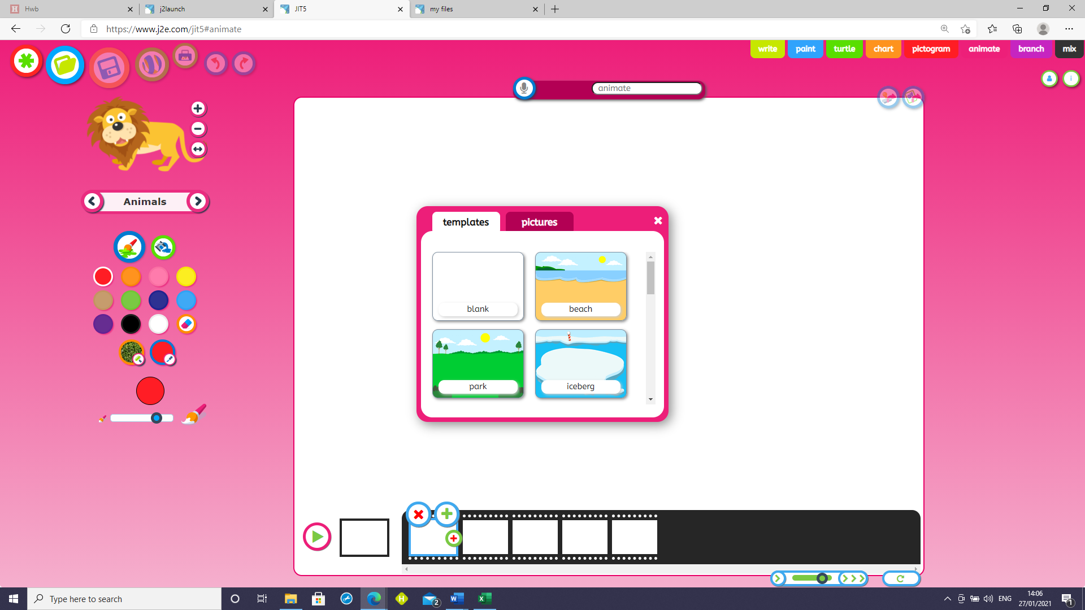  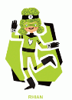 |  | Mental Health and Well-being Week – Express yourself  This week we are celebrating Children’s mental health and well-being and the topic is express yourself. We will have a live teams meeting on Monday at 1pm where we will do a circle time activity where I will ask children questions for them to express themselves.  The Bog Baby  Listen to the story – The Bog Baby. Were your predictions correct.  Imagine you were the Bog Baby. Write a diary account to say How you were feeling when the little girls caught you in the net.  Flipgrid code  https://flipgrid.com/27895cd0  P.E.  Join in workouts with Joe Wicks on a Monday, Wednesday and Friday.  Mrs Watts PSD Challenge:  Draw what makes you happy on the resource sheet, 'Things that make me happy'.  Mrs Watts PE:  This week, try yoga using the link: Squish the Fish | A Cosmic Kids Yoga Adventure! - YouTube  

