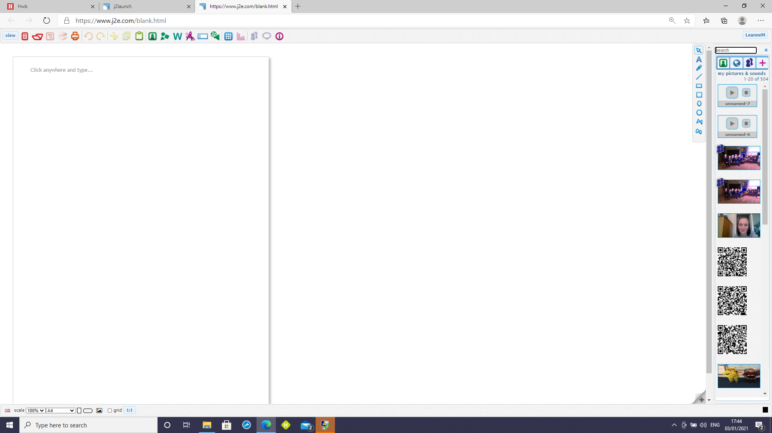
.
4. Drag you picture onto the page.
3. Click on the world to search.
2. Type a word that you would like to search.
- Click on picture icon.

