 | Look    This Photo by Unknown Author is licensed under CC BY | Cover  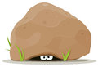 | Write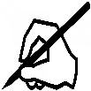 | Check    This Photo by Unknown Author is licensed under CC BY
said
they
you
what
there
some
were

These are high frequency words that the children use daily. They do not sound like the way that you spell them. Children often find these tricky and confuse the spellings. Learn these spellings and test your child daily on them.

