  Date: January 6th 2021 |  |  |  | Theme: Wriggle and Crawl.  Year group: Mrs Moore Y1/2
Literacy      This Photo by Unknown Author is licensed under CC BY-NC-ND   | Numeracy     | Creative     | Thinking     |  | Healthy me    
Spelling – Practice reading and writing the words on the spelling sheet. Look, cover, write, check each of the words.  Rising Stars – Read assigned book on the Rising stars website and complete questions on book.  Literacy – Make a sandwich with an adult.  - Talk about what you are going to need.  - Fetch the ingredients.  - Make the sandwich.  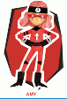  Write a set of instructions for your friend to make your favourite sandwich when you go for tea.  Welsh - Read the words for each type of weather.  Tell your family what the weather is like to day using the sentence:  Mae hi’n ………………… /It is ………….  Focus  Write a weather report for todays weather.  Draw a picture of the weather for each day of the week. Write the sentence to match each of the pictures.  Mae hi’n ………………… /It is …………. | My Maths – Year 1 and Year 2 counting boost activities.  Numeracy  My Maths – Multiplication  Pages 1-3.  Focus  This week we will be starting to use the division symbol. Give your child 24 objects (Lego, sweets, fruit etc). Ask your child to share the objects equally in to two piles, then three piles, then four piles. Each time asking how many is in each pile.  Complete activity sheet – Sharing between the owlets.  Numeracy – Time (Intro)  Story: The Hungry Caterpillar – you can access this story via you tube.  Focus  Write the days of the week in order – Draw which fruit he had on each day.  Maths Attack  Practice counting in twos with your child. | Creative Challenge  This term we will be creating our own still life paintings.  Read through the power point presentation on the famous artist Vincent Van Gogh. Create your own version of his ‘Sunflower’ painting.     | Garden Visit.  Take children outdoors to observe minibeasts. If you cannot get outdoor the children could look at videos on you tube.  Ask them to listen to an expert describe how the environment supports the animals that live there. (You Tube)  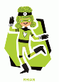  Focus - Draw a picture of a minibeast and label. Write notes about how they moved.  ICT  Using J2E 5 write an alphabetical list of what they saw in the garden. If they have not got access to a garden, look at pictures on the internet and write a list using the picture. Add pictures to their list by:  - Clicking on the picture icon.  - Typing in what they would like to find in the search tab.  - Click on the world icon.  - Drag the picture onto the page. |  | Myself as a baby  Talk to your family, and gather information about what you were like as a baby.  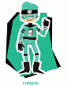  Complete the worksheet (like the one below). The worksheet is on the webpage.  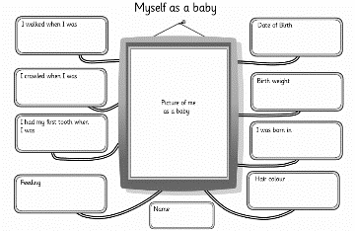  P.E.  Jumping:  See how far you can jump, starting and landing on two  feet. Use an object to mark how far you have jumped and  then see if you can improve. You could have a competition  against someone at home to see who can jump the furthest.  Remember to bend your knees when you take off and when  you land. Use your arms to help you to jump further.  Balancing:  Find an object at home (e.g. a small soft toy) and practise  balancing it on different parts of your body.  Can you balance it on your head, bent knee, shoulder,  arm or foot?  Can you sit or kneel down and stand back up again with the object still balanced.  

