 | Look    This Photo by Unknown Author is licensed under CC BY | Cover  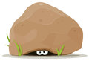 | Write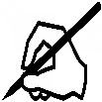 | Check    This Photo by Unknown Author is licensed under CC BY
coast
roast
toast
shrink
blink
think
thing
so
do
some

Learn these spellings. I will post a spelling quiz on Friday on HWB.
Choose 5 of the words and write a sentence using those words.

