  Date: January 18th 2021 |  |  |  | Theme: Wriggle and Crawl.  Year group: Mrs Moore Y1/2
Literacy      This Photo by Unknown Author is licensed under CC BY-NC-ND   | Numeracy     | Creative     | Thinking     |  | Healthy me    
Spelling – Practice reading and writing the words on the spelling sheet. Look, cover, write, check each of the words.  Rising Stars – Read assigned book on the Rising stars website and complete questions on book.  Literacy – Narrative (Story Writing)  Watch the following video with an adult –  https://www.literacyshed.com/butterflies.html  Questions to ask: Pause the film after 17 seconds when the man sits down with the book. What do you think might happen to the book? Why do you think the clip is called Book of Butterflies?  Pause the film at 33 seconds. Why do you think the man is reading a book about butterflies? What kind of information do you think is on the pages? What do you know about butterflies? What colour is the background? What feeling does this give to the film?  Pause the film at 48 seconds as the butterflies fly out. Did this surprise you Is the man surprised? How do you know? What else might happen?  Pause at 52 seconds. How many butterflies have come out of the book? What colours are they? What colour is the background now? What feeling does it give to the film now?  Play to the end. What do you think the man might do to get the butterflies back into the book?  The Hungry Caterpillar  Use the sequencing cards to retell the story of the Hungry caterpillar. Tell the story to your family.  Book of Butterflies activity  Match the pictures to the correct collective noun.  Adding ing  Add ing to creative a new word. (Verbs)  Welsh –  Tric a Chlic – Listen to the story ‘Y gath’.  Match the sentences to the pictures.  Dillad/Clothes  Slot Drillio – Clothes Flashcards  Focus  - Labelling the clothes to match the weather using the welsh word mat.    - Create a poem about ‘Dillad Smart’ – ‘Smart Clothes’. | My Maths – odds evens and multiples.  Numeracy  Introduction  My Maths – 2 times table  Focus  2 Times Table and division challenge.  Numeracy – Time (Intro)  My Maths – Understanding Time.  Focus    This week we will be looking at ‘half past and quarter past and quarter to’.  Share power point with your child’.  Point out half past, quarter past and quarter to times around the home using analogue and digital clock.  Complete activities on My Maths and work sheets  Maths Attack  Practice counting in fives with your child.  Make a 5times Table Fortune Teller.  Use j2blast on Hwb to practice your times tables.     | Expressive Arts  Art  Choose a painting done by Georgia O Keefe. Recreate the painting by using objects around your home.  Example  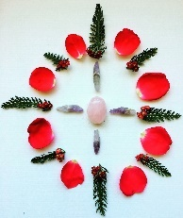  (Additional Planning for these areas will be added by Mrs Watts) | Minibeast survival.  Think about the creatures that they have seen and explain what they think minibeasts need to survive. Complete a table or annotate pictures of the minibeasts with information under the following headings: What do I eat and drink? How do I breathe? What do I live in or under? How do I protect myself?  Note: A slug for example: What do I eat and drink? – living and dead plants; How do I breathe? – breathe air through a breathing hole; What do I live in or under? – damp, dark places, under rocks and wood; How do I protect myself? – camouflage and slime.  ICT  In HWB find J2code  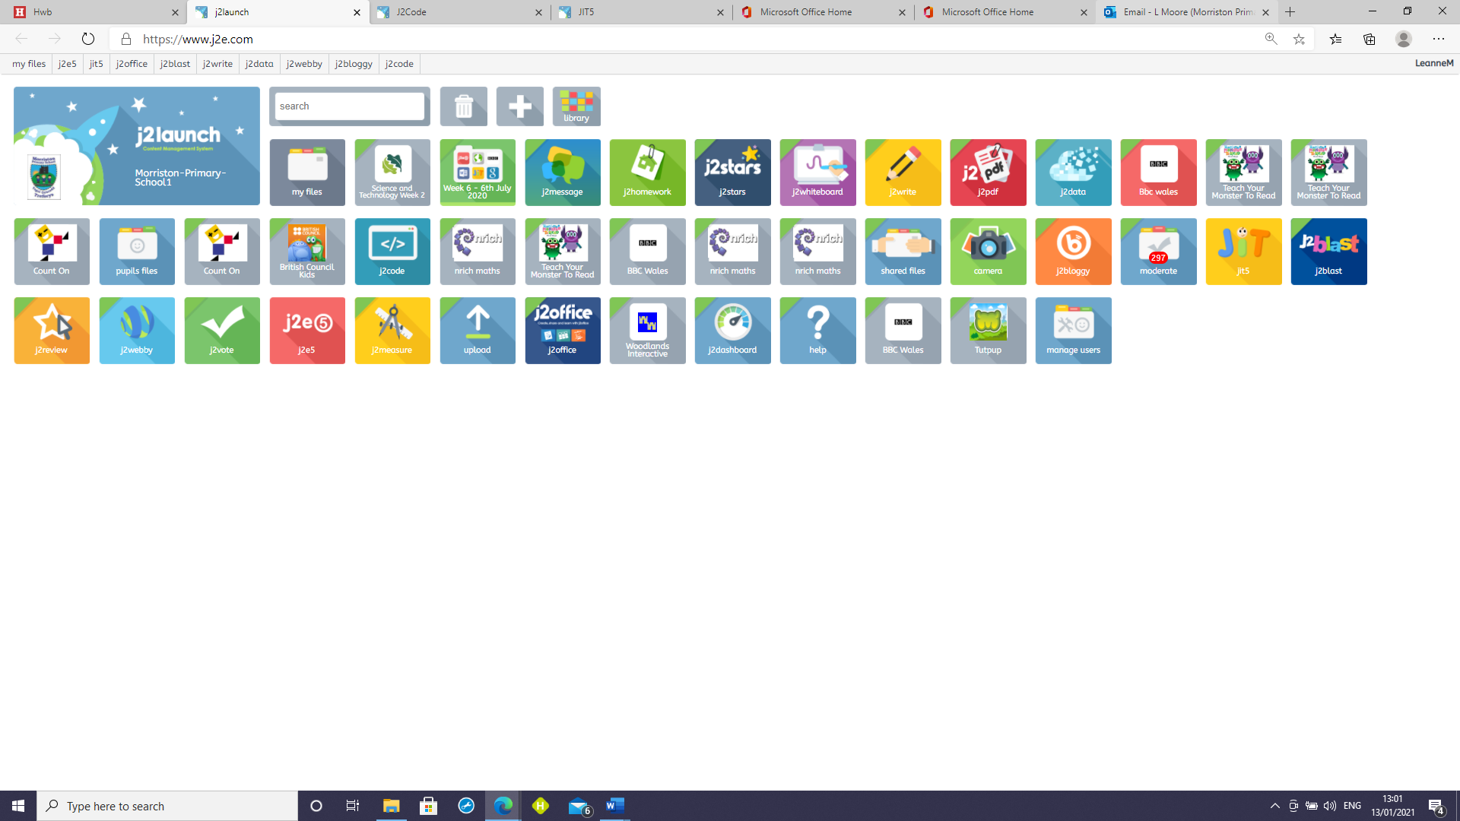 then 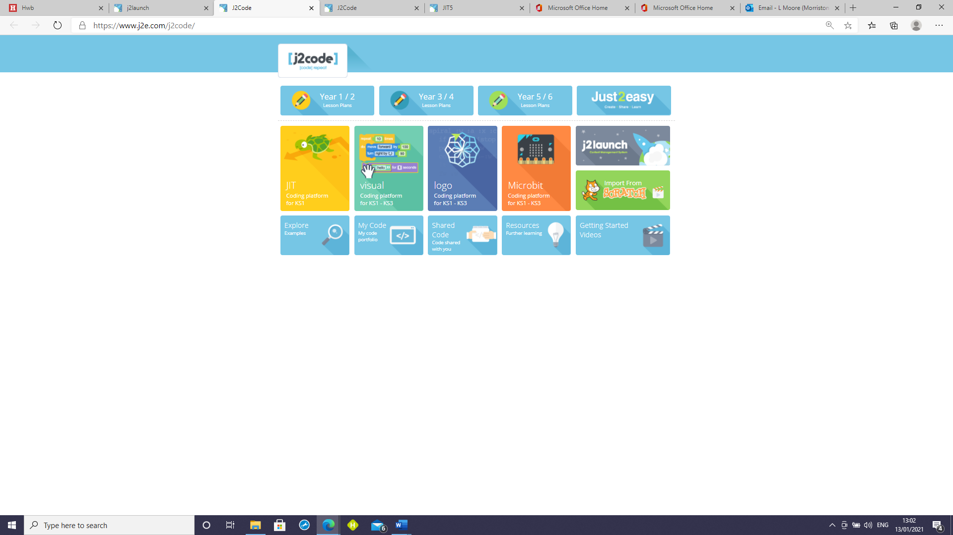J2code.  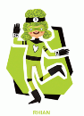  Create an algorithm to help the butterfly visit on the flowers. |  | Health and Well-being  PSD  Write a set of instructions that inform others how to care for a minibeast, referring back to their features checklist to help them with their writing. Use a range of bossy verbs at the start of each sentence, choosing the most appropriate for the instruction. Give their instructions a title, such as: ‘How to care for a worm’ or ‘How to keep a spider  P.E.  Tune into P.E with Joe Wicks at 9.00am ON Monday, Wednesday and Friday mornings.  (Additional Planning for these areas will be added by Mrs Watts)  Flip Grid – Book review  

