  Date: 12/2/21 |  |  | Theme: Wriggle and Crawl  Year group: 1/2
Creative     | Thinking     | Healthy me    
Creative Challenge  Use the materials to create the life cycle of a Honeybee at each stage.  - Egg  - Larvae  - Pupal  - Adult  Thursday - World Book Day  During challenge time children will be designing a bookmark with their favourite character. On the back of the bookmark children will write about their character explaining why they are their favourite. | Tuesday - Humanities: Session 3 – Introduction (St David’s Day)  Ask what we already know about St David’s Day. Why, who and How do we celebrate. Use a KWL grid and add their ideas onto post its. Read St David’s Day PowerPoint/story.  LM: Focus: Letter Writing  Show children an example of a letter. Why do we write letters? What do we need to include in our letter? We are going to imagine we are St. David, and we are writing a letter to our mother Non. Telling her about the Monastery and the tasks you have been doing.  LM: Group 3: Write about one part of his journey. E.g., The Monastery is…… and repeat.  LS: Group 1 – St David’s Day craft  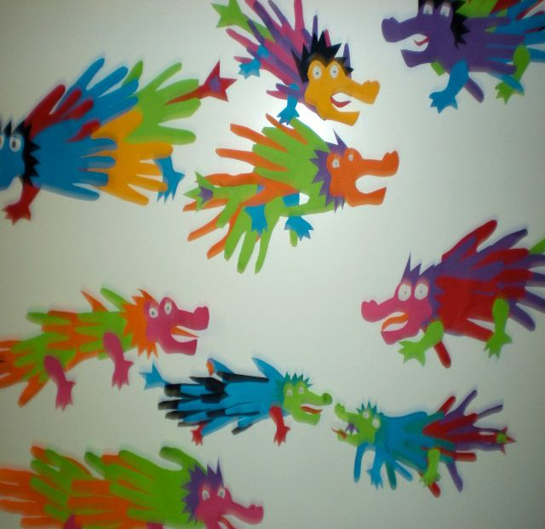  SS: Group 2 – Challenges.  Session 4  LM: Group 1: Write a letter telling Non about all parts of his journey, use report planner and pictures as a model.  LS: Group 2: St David’s day craft.  SS: Group 3: Challenges.  Wednesday - Humanities: Session 1  SS: Group 2 - Caterpillars: Write a letter with support. Display pictures and create a word list to support for the main points in letter.  Friday Session 1 – 4 Science and Technology  Children will be engaging in Marvin and Milo experiments.  There will be a carousel of 3 Science experiments.  ICT Challenge  Use JIT 2Animate to create an animation to show the life cycle of a Honeybee. | P.E. (Mrs Watts)  Health and Well-being (Mrs Watts)

