  Date: ^{1st} March2021 |  | Theme: Wriggle and Crawl  Year group: 1/2
Literacy      This Photo by Unknown Author is licensed under CC BY-NC-ND   | Numeracy    
Catch-up: Lisa (Monday/Tuesday)  Sentence Building  Build sentences using the St David’s day vocabulary. Write sentences on a whiteboard.  Monday Session 1 – Literacy – Introduction  Write ‘Wriggle and Crawl’ on board – Discuss, names, features etc.  Show picture of a ‘Honeybee’. What do they know?  Watch a video all about Bees.  LM: Focus – Record what they know about Honeybees.  Group 1: Draw a picture of the Honeybee and record any information they have or any questions that they would like to find out. Model using report planner.  SS: RWI - Group 2: Green books.  LS: Challenges - Group 3  Tuesday Session 1 – Literacy – Introduction  Recap information they shared on Honeybees. Watch another video with additional information.  LM: Focus – Record what they know about Honeybees.  Group 2: Draw a picture of the Honeybee and record any information with support. Provide children with word mat. Model using report planner.  SS: RWI - Group 3: Red books.  LS: Challenges - Group 1  Catch-up: Lisa (Thursday/Friday)  Work on letters m, a, s. Write letters on whiteboard using whooshes in and out. Write the words am, as and Sam using joined letters.  Readers: Sian  Thursday Session 1 – Literacy – Introduction  Recap information they shared on Honeybees.  LM: Focus – Record what they know about Honeybees.  Group 3: Provide a picture of the Honeybee and record any information using sentences, orally compose first and then encourage children to write using word mats.  Bees can…….  Bees will …….  Bees are …….  SS: RWI - Group 1: Orange books.  LS: Challenges - Group 2  Word Time – 10 mins (Daily)  Phase 4 Spellings  Story Time – 10 minutes at the end of the day.  Monday – Session 3 - Welsh – Introduction  Read the story Parti Doli Glwt – encourage children to join in with familiar parts.  Doli glwt would like to know what foods we like ready for her next party. Display question and answer, encourage children to ask partner question and answer.  LM/LS: Focus  Create a tally chart of favourite party foods.  LM: Group 1: Fill in tally independently.  LS: Group 3: Pictures and names of foods provided, support children to answer.  SS: Tric a Chlic – Gwyrdd – Group 2  - Introduce new sounds.  - Say sounds write on white board.  - u, d, ll, I, ch read through book.  - Match words to picture game.  Challenge – Cwtch Cymraeg.  Sort the foods into a food I like and don’t like using a Venn Diagram.  Slot Drillio – Food Flashcards  Friday - Session 4 – Guided Reading/DIRT TIME/EPIC Planning.  15 minute rotation.  Guided Reading/Rising Stars – Leanne  Differentiation  Spiders – Green Books – The Big Show  Caterpillars – Yellow Books – Night Travels  Worms – Red Books – The Wolf and the Kids  EPIC Planning – SS  DIRT Time - LS | Catch-up: Lisa (Wednesday)  Matching halves and quarters  Monday Session 2 – Numeracy – Recognising Quarters – Introduction (Number)  Cut apple in half: Discuss how many parts? Record ‘One Half ½ ‘.  Cut apple again: Discuss what I have done now? How many parts? What is this called? Record one quarter ¼ ‘.  In ¼ what does the 1 represent?  What does the 4 represent?  How do you know that you have shaded one quarter?  How many quarters make a whole?  Demonstrate using real life objects.  LM: Focus – Group 3 - Is it a quarter.  LS: Games – Group 1 - Give children a sheet of paper with 4 hoops. Children choose a number and share that amount between the four hoops. How many in each group? Write on ¼ 0f 4 = 1 (Take pictures and stick into books.)  SS: Group 2 – Challenges  Tuesday Session 2 – Numeracy – Recognising Quarters – Introduction (Number)  My Maths – Recognising Fractions.  LM: Focus – Group 1 – Read and shade the fractions.  LS: Games – Group 2 - Give children a sheet of paper with 4 hoops. Children choose a number and share that amount between the four hoops. How many in each group? Write on ¼ 0f 4 = 1 (Take pictures and stick into books.)  SS: Group 3 – Challenges  Thursday Session 2 – Numeracy – Recognising Quarters – Introduction (Number)  My Maths – Recognising Fractions.  LM: Focus – Group 2 – Read and shade the fractions with support.  LS: Games – Group 3 - Give children a sheet of paper with 4 hoops. Children choose a number and share that amount between the four hoops. How many in each group? Write on ¼ 0f 4 = 1 (Take pictures and stick into books.)  SS: Group 1 – Challenges  Maths Challenge – Half it/Share it  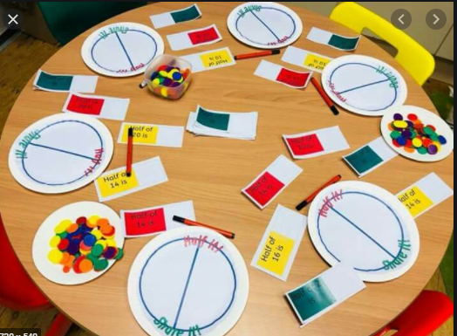  Maths Attack – 10 times table (10 minutes daily)  Thursday Session 3 – Shape, Space and Measures: (2d Shapes)  Introduction  Shape feely bag – Pull out shapes and ask what they are, describe each shape and label them.  LM/SS: Focus - Recognising 2d shapes and naming them.  LM: Spiders: Shape hunt around the classroom, fill in the table.  SS: Caterpillars: Shape hunt around the class, create a tally chart of the shapes they have found.  LS: Games – Look for shapes in the outdoors/2d shape bingo.  Create a picture using 2d shapes.  Thursday Session 4 – Shape, Space and Measures: (2d Shapes)  LM: Worms: Shape hunt around the school/outside – Take pictures of what they have found.  SS: Spiders – Shape Bingo  LS: Caterpillars - Look for shapes in the outdoors/2d shape bingo.  Create a picture using 2d shapes.  .

