  Date: 3/9/2020 |  |  |  | Theme: Do Cows Drink Milk?  Year group: STF1
Literacy      This Photo by Unknown Author is licensed under CC BY-NC-ND   | Numeracy     | Creative     | Thinking     |  | Healthy me    
Before starting to learn the sounds and letter names again we will be checking to see how many sounds and letters the children remember by completing in class Read, Write, Inc assessments. If you would like to do this with your child in class you can write down all of the letters in the alphabet and ask them to say the sound for each. If they are able to say all sounds, you can then ask if they know the letter names (level 2).  News – Children will be sharing their news with their class from the summer holidays. Level 1 - Children will then be recording their news with an adult – either by mark making and drawing picture (an adult will then scribe to say what they have written about) or Level 2 - children will be writing key words and drawing a picture.  IEP target – an adult will work with a child on a 1-1 basis so they can have an opportunity to practise their literacy IEP target. | Before starting our maths planning for the term we are going to check which maths skills the children remember. Using a number square we will be asking the children the number and marking off all of the numbers they know. We will use flash cards for the days of the week and months of the year, seeing if the children know what they are either by reading or in song. We will also check if they can order them.  As well as numbers and days/months we will be using our 2d shapes to check if the children know the 2d shape names or if they can match the shapes.  Please feel free to do this at home with your child this week.  If you would like to use some number games at home there are a range on topmarks website, you can also log into your child’s ‘mymaths’ account.  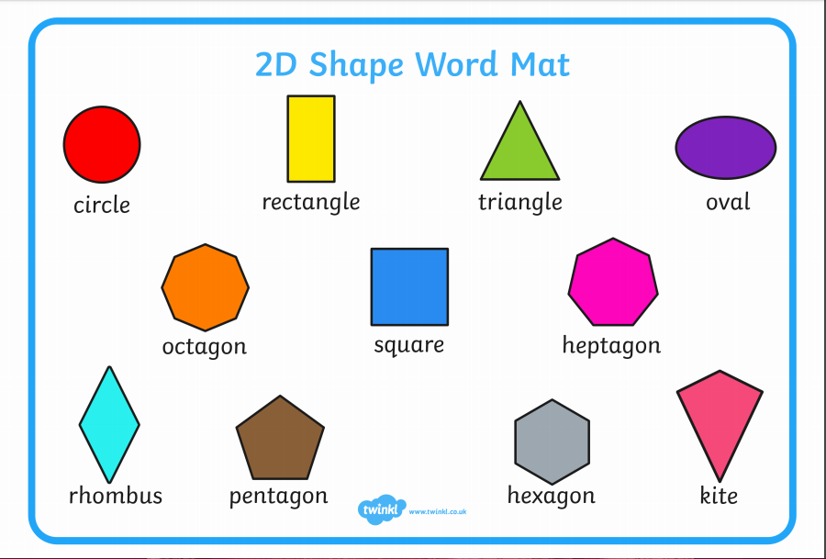  IEP target – an adult will work with a child on a 1-1 basis to develop their numeracy IEP targets. | This week we will be asking the children to draw pictures of their family so that we learn who is in their immediate family. | Our new topic will start next week, I will upload information about this topic on the class webpage and also on class dojo. |  | Joe Wicks is back! You can subscribe to his channel to keep up to date with his new videos.  If you would like to try something different we enjoy Cosmic Kids yoga in class found on Youtube.



