  Date: 3/9/2020 |  |  |  | Theme: Do Cows Drink Milk?  Year group: STF1
Literacy      This Photo by Unknown Author is licensed under CC BY-NC-ND   | Numeracy     | Creative     | Thinking     |  | Healthy me    
Carried over from last week for children who were not in - Before starting to learn the sounds and letter names again we will be checking to see how many sounds and letters the children remember by completing in class Read, Write, Inc assessments. If you would like to do this with your child in class you can write down all of the letters in the alphabet and ask them to say the sound for each. If they are able to say all sounds, you can then ask if they know the letter names (level 2).  RWI Monday - Thursday – The sound of the week is m. We will be listening and singing along to our two favourite sound songs - https://www.youtube.com/watch?v=YiK7IL0kqd0 and https://www.youtube.com/watch?v=3iYEOuyA-6o. We will be looking through pictures to work out the word that has m in it. We will be learning to read words that start with m and having a go at writing these down. Level 1 – forming m in a range of multisensory ways. Level 2 – writing words that has m in it.  Wednesday - Spelling – In preparation for our spelling quizzes we will be assessing the children to find the appropriate level for their spelling words.  Monday - News – Children will be sharing their news with their class from the weekend. Level 1 - Children will then be recording their news with an adult – either by mark making and drawing picture (an adult will then scribe to say what they have written about) or Level 2 - children will be writing key words and drawing a picture.  Thursday - Text type – This term out text type is recount. This week we will be looking at our recount pack which includes a description of what a recount is, words that we may use in a recounts eg time connectives and a good example of a recount.  IEP target – an adult will work with a child on a 1-1 basis so they can have an opportunity to practise their literacy IEP target. | Carried over from last week for the children who were not in - Before starting our maths planning for the term we are going to check which maths skills the children remember. Using a number square we will be asking the children the number and marking off all of the numbers they know. We will use flash cards for the days of the week and months of the year, seeing if the children know what they are either by reading or in song. We will also check if they can order them.  As well as numbers and days/months we will be using our 2d shapes to check if the children know the 2d shape names or if they can match the shapes.  Please feel free to do this at home with your child this week.  If you would like to use some number games at home there are a range on topmarks website, you can also log into your child’s ‘mymaths’ account.  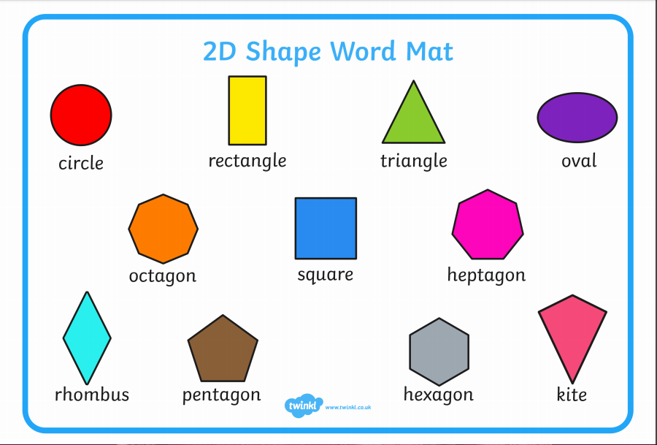  Monday and Wednesday Level 1 - Number of the week – We will be starting with 0. We will listen to one of our favourite maths singers – Jack Hartman - https://www.youtube.com/watch?v=epEq3HXtkZE We will practise forming 0 and using plates/fruit to show that we don’t put any down for zero. We will also use a whiteboard with 0 and 1 listed to show we don’t put any down for zero and we put 1 piece of fruit down on the plate for 1.  Monday and Wednesday - Level 2 – number assessment - Recite numbers to 100, forwards and backwards, and from different starting points. Children will read/match/say/identify and write numbers to 100 to identify how many and if there are any formation problems. Children will play a bingo game containing numbers 0 – 100 for further practise in identifying these numbers.  Tuesday - Shape, space and measure lesson – Level 1 - compare, sort and order two objects in terms of size, by direct observation  Children will work with an adult to sort big and small bears. Using the vocabulary if possible/signing/matching/sorting.  Level 2 – Children will be assessed to ensure they are also able to identify/sort and use size vocabulary with the bears and also using the IWB interactive games.  On Thursdays we use the digital devices to develop our maths skills as well as digital skills. Children will be using ipads/beebots/computers and interactive whiteboards to play a range of games on Topmarks to consolidate their learning for the week in the number lessons eg this week we looked at number recognition and measure.  IEP target – an adult will work with a child on a 1-1 basis to develop their numeracy IEP targets. | This week we will be asking the children to draw self-portraits. Children will have individual mirrors or we will take their picture using an ipad so that they can copy. Children will be asked to fill as much of paper as possible to ensure their drawings are not too small. Children will be asked to look at all of the details eg what shape are their eyes? How big should they draw their nose? What colour are their lips? So that they can add further details.  Level 1 – children will look at their image/reflection with an adult who will point to each part of the face and ask the child to point to or repeat. Children will then mark make to complete.  Level 2 – children will be drawing with some independence and support from an adult. An adult will remind them if they have missed any parts of their face or with the colours.  Music – we follow the music scheme online called Charanga. Each week we listen to one song while dancing and deciding if we like it. We then answer questions such as was it fast or slow? What instruments did you hear? We then listen to songs to find the beat/pulse and find it in different ways eg tapping, clapping, nodding, clicking. We then learn the song and sing the song. If you would like to sing at home with your child there are a range of nursery rhymes on Youtube to sing along to. | Introduce our new topic – Do Cows Drink Milk. Lead the children into our role play area where we have set up a farm, have farm games and a range of farm animal puppets. We will ask the children what they think our new topic is about. We will ask the children if they can name any of the animals on the farm and tell us what noises they make. We will show farm machinery and ask if the children know what they are called and what they may be used for. We will then take the children to the interactive whiteboard where they will watch the introductory video – Who lives on a farm? The children will see a farmhouse, animals in the farm and the produce that come from animals.  The children will then watch the sheep dog video to see that it is not only the farmer who works on the farm.  Finally the children will watch the farm shop video to see the farm produce being sold.  If you are starting the topic at home you will be able to find a range of farm videos for children on Youtube.  After the children have found out about their topic they will be asked to fill out a ‘what I know and what I want to find out sheet’ (below).  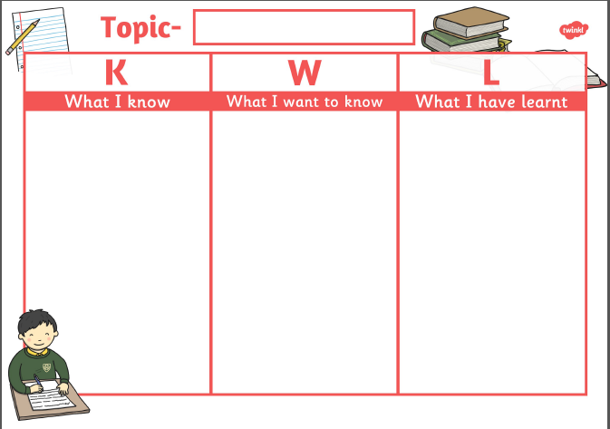  Level 1 – Children will sign/point to/name animals that they know and mark make to record.  Level 2 – working with an adult, children will either draw pictures to record or write to show what they know.  Children can then draw a farm scene. |  | Joe Wicks is back! You can subscribe to his channel to keep up to date with his new videos.  If you would like to try something different we enjoy Cosmic Kids yoga in class found on Youtube.  Playdough disco – before writing activities children will be warming up their hands and fingers by taking part in playdough disco (with their own individual pots of labelled playdough).  PD Wednesday – children will be using the bikes, cars and scooters on the yard to develop their skills.  PE Thursday – Children will be playing follow the leader games to warm up and so that we can see which skills children can do eg walking around the hall, hopping around the hall, skipping around the hall, jumping around the hall and jogging around the hall. Children will then play ball skills so that they can get to know each other’s names and practise ball skills. Children will first call a friends name and roll to their friends. They will then bounce to their friends. Children will move on to throwing to their friends and kicking to their friends. We wall use these skills – roll, throw, bounce and kick while passing the ball around the circle and then as a way of travelling the ball back to class for a cool down.

