What do I already know?
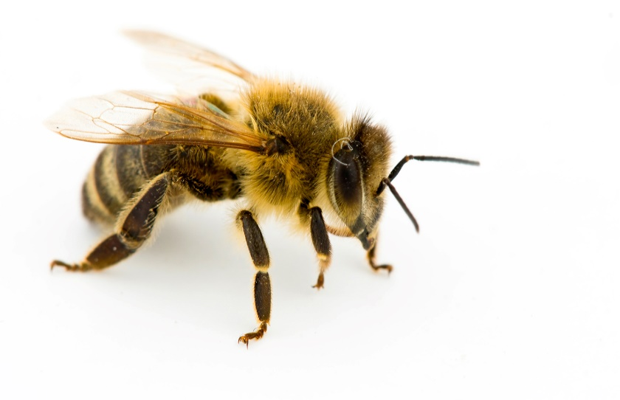

What do I already know?

