  Date: 14/9/2020 |  |  |  | Theme: Do Cows Drink Milk?  Year group: STF1
Literacy      This Photo by Unknown Author is licensed under CC BY-NC-ND   | Numeracy     | Creative     | Thinking     |  | Healthy me    
Carried over from last week for children who were not in - Before starting to learn the sounds and letter names again we will be checking to see how many sounds and letters the children remember by completing in class Read, Write, Inc assessments. If you would like to do this with your child in class you can write down all of the letters in the alphabet and ask them to say the sound for each. If they are able to say all sounds, you can then ask if they know the letter names (level 2).  RWI Monday - Thursday – The sound of the week is a. We will be listening and singing along to our two favourite sound songs - https://www.youtube.com/watch?v=hBAuIzZttP4 and https://www.youtube.com/watch?v=ZwxnPcvseVo We will be looking through pictures to work out the word that has a in it. We will be learning to read words that start with m and having a go at writing these down. Level 1 – forming a in a range of multisensory ways. Level 2 – writing words that has a in it.  Wednesday - Spelling – The children will be tested on their spelling words. The children will listen to the word and have a go writing. Any words that are not correct the children will have another practise by writing the word three times.  Readers – Children will be listened to reading Tuesdays and Fridays.  Monday - News – Children will be sharing their news with their class from the weekend. Level 1 – An adult will prompt the child, either by showing pictures that parents have sent in from the weekend on classdojo or by signing/using key words eg park? Beach? Children will then be recording their news with an adult – either by mark making and drawing picture (an adult will then scribe to say what they have written about) or Level 2 - children will be writing key words and drawing a picture.  Thursday - Text type – This term out text type is recount. This week we will be looking at our recount pack which includes a description of what a recount is, words that we may use in a recounts eg time connectives and a good example of a recount. Using the example from last week the children will either by sorting the pictures (level 1) or ordering the recount eg title at the top, sentences and pictures in order (level 2).  IEP target – an adult will work with a child on a 1-1 basis so they can have an opportunity to practise their literacy IEP target.  Welsh – recap last week’s word of the week ‘Croeso.’ All repeat the word, look at the spelling and read the word, copy write the word. Say the word to a friend, say it to an adult. Introduce this week’s word of the week. Practise the sentence pattern – Pwy wyt ti? ……ydw i. Practise reading both, practise copy writing. Ask and answer with a friend. | Carried over from last week for the children who were not in - Before starting our maths planning for the term we are going to check which maths skills the children remember. Using a number square we will be asking the children the number and marking off all of the numbers they know. We will use flash cards for the days of the week and months of the year, seeing if the children know what they are either by reading or in song. We will also check if they can order them.  As well as numbers and days/months we will be using our 2d shapes to check if the children know the 2d shape names or if they can match the shapes.  Please feel free to do this at home with your child this week.  If you would like to use some number games at home there are a range on topmarks website, you can also log into your child’s ‘mymaths’ account.  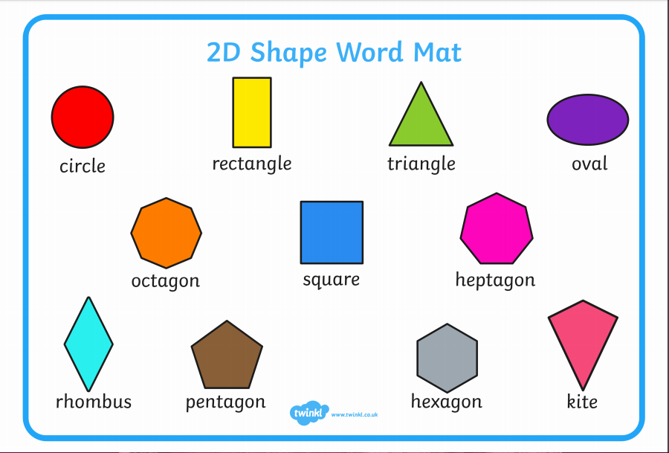  Monday and Wednesday Level 1 - Number of the week – We will be starting with 1. We will listen to one of our favourite maths singers – Jack Hartman - https://www.youtube.com/watch?v=epEq3HXtkZE We will practise forming 0 and using plates/fruit to show that we don’t put any down for zero. We will also use a whiteboard with 0 and 1 listed to show we don’t put any down for zero and we put 1 piece of fruit down on the plate for 1.  Monday and Wednesday - Level 2 – following on from last week’s number assessment. The children will have their own targets from the outcomes of their assessments. The children will be working with a given set of numbers (either to 20 or to 100). The children will be ordering numbers and practising the formation. The children will be asked to write the next two numbers in the sequence starting from a given number.  Tuesday - Shape, space and measure lesson – Level 1 - compare, sort and order two objects in terms of size, by direct observation  Children will work with an adult to sort big and small bears. Using the vocabulary if possible/signing/matching/sorting. The children will be working on last week’s target before moving on.  Level 2 – Children will be assessed to ensure they are also able to identify/sort and use size vocabulary with the bears and also using the IWB interactive games. The children will be working on last week’s targets before moving on.  On Thursdays we use the digital devices to develop our maths skills as well as digital skills. Children will be using ipads/beebots/computers and interactive whiteboards to play a range of games on Topmarks to consolidate their learning for the week in the number lessons eg this week we looked at number recognition and measure.  IEP target – an adult will work with a child on a 1-1 basis to develop their numeracy IEP targets. | Last week the children thoroughly enjoyed creating self-portraits. This week we will be asking the children to choose a friend in class to draw a picture of them. Children will be asked to take a picture of their friend using an ipad so that they can copy. Children will be asked to fill as much of paper as possible to ensure their drawings are not too small. Children will be asked to look at all of the details eg what shape should they draw the eyes? How big should they draw the nose? What colour are the lips? So that they can add further details.  Level 1 – children will look at the picture of their friend with an adult who will point to each part of the face and ask the child to point to or repeat. The children will be asked to repeat their friends name/point to their friend. Children will then mark make to complete.  Level 2 – children will be drawing with some independence and support from an adult. An adult will remind them if they have missed any parts of their friends face or to colour in with the correct colours.  Music – we follow the music scheme online called Charanga. Each week we listen to one song while dancing and deciding if we like it. We then answer questions such as was it fast or slow? What instruments did you hear? We then listen to songs to find the beat/pulse and find it in different ways eg tapping, clapping, nodding, clicking. We then learn the song and sing the song. If you would like to sing at home with your child there are a range of nursery rhymes on Youtube to sing along to. | Ask the children what our new topic is? Do cows drink milk? Ask the children what they remember for our topic introduction? Remind the children of the videos that we watched. Show the children some of the ‘what I know/what I want to know’ grids. Tell the children that some of the children wanted to find out about different farm animals so each week we will be looking at a different animal. We will researching what the animal looks like, what sound it makes, how it moves, what colour it is/can be, what food it eats, where it lives etc and we will be sharing a story about the animal.  This week we will be looking at cows. We will research information on cows by viewing a range of videos such as - https://www.youtube.com/watch?v=-MJOnKU8wdI, https://www.youtube.com/watch?v=frcAf4ks9_s and https://www.youtube.com/watch?v=AuEX9umtfLM,  The children will be making a fact file of the animal of the week listening its name, labelling diagrams, writing what they eat, any produce they make, baby names and any other information they can remember.  We will all be engaging in a shared piece of art for our display to show that we have learnt about that animal.  We will be showing children milking demonstration videos and they will have a turn ‘milking a cow’ by using a surgical glove filled with watered down white paint. An adult will prick the fingers of the gloves and children can pretend to milk the cow outside.  We will be sharing story books about cows.  Level 1 – Children will sign/point to/name animal of the week. The children will over write/mark make to write the name and draw a picture of the animal.  Level 2 – Children will name, say the noise, draw a picture and write key words/sentences to record the information that they have found out about the animal.  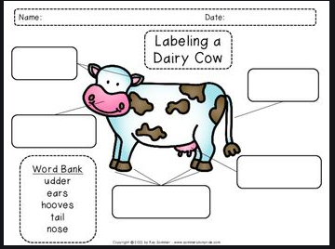   |  | Joe Wicks is back! You can subscribe to his channel to keep up to date with his new videos.  If you would like to try something different we enjoy Cosmic Kids yoga in class found on Youtube.  Playdough disco – before writing activities children will be warming up their hands and fingers by taking part in playdough disco (with their own individual pots of labelled playdough).  PD Wednesday – children will be using the bikes, cars and scooters on the yard to develop their skills.  PE Thursday - This week the animal of the week for the topic was the cow. We will watch a video to see how cows move and will try to act this out. Each week we will add to the animal movements. An adult will call animals names out and the children will move in that way.  The farmer’s den! Sing the action song The Farmer’s in his Den. Ask the children to make a circle and hold hands. Choose a ‘farmer’ to stand in the middle of the circle then ask the circle of children to walk around the farmer as they sing the first verse of the song. Then, ask the children to stop, and allow the farmer to choose a husband or wife. The song and actions continue until the farmer has chosen a husband or wife, a child, a nurse, a dog and finally a bone. At the end of the song, everyone gathers round and sings the last line as they gently pat the child who was chosen to be the bone.

