 | Look  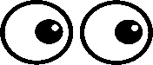  This Photo by Unknown Author is licensed under CC BY | Cover  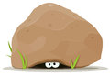 | Write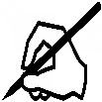 | Check    This Photo by Unknown Author is licensed under CC BY
little
when
looked
come
will
children
about

These are high frequency words that the children use daily. They do not sound like the way that you spell them. Children often find these tricky and confuse the spellings. Learn these spellings and test your child daily on them.

