  Date: 22ND February 2021 |  | Theme: Wriggle and Crawl  Year group: 1/2
Literacy  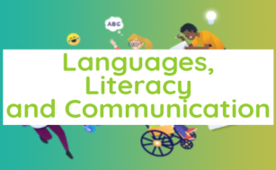      This Photo by Unknown Author is licensed under CC BY-NC-ND | Numeracy  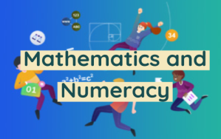  
Lisa - Catch-up: Literacy  Adjectives – read and sort the adjectives to describe the minibeasts.  Sian – Readers  Literacy - Introduction  Read the story ‘The Bad-Tempered Ladybird’. Display a picture of the Lady bird. Ask children to share adjectives to describe the Ladybird. Create a book review on the story.  Leanne – Focus  Differentiation  Spiders – Write a book review independently. Model writing a review. Remind children to use adjectives to describe the characters and to use connectives to extend their sentences.  Caterpillars – Write a book review with some support. Provide children with adjectives to use and pictures of the possible favourite parts they could write about.  Worms – Write a book review with support. Build sentences with children using whiteboards to describe the character use a picture of a part of the story that the children can write about.  Sian – Read, Write, Inc  Spiders – Orange Books  Caterpillars – Green Books.  Worms – Red Books  Clare – Challenges  Formation Station – Copy the ladybird poem.  Writing Challenge – Write a character description for the Bad - Tempered Ladybird. Use 5 adjectives in your description.  Reading Challenge – Place three different books about minibeasts. Children to award first prize to their favourite book and record on a class bar chart.  Word Time – 10 mins (Daily)  Phase 4 Spellings - Week 5  Story Time – 10 minutes at the end of the day.  Welsh – Introduction  Read the story Parti Doli Glwt – encourage children to join in.  Focus – Leanne/Lisa  Create a tally chart of favourite party foods.  Create a graph on JIT 5 Data.  Differentiation  Spiders – Work independently asking the question and recording results.  Caterpillars – Support the children when asking the question and recording results children can work with a partner.  Worms – Work as a group to ask the question and record the answer.  Tric a Chlic – Gwyrdd - Sian  - Introduce new sounds.  - Say sounds write on white board.  - u, d, ll, I, ch read through book.  - Match words to picture game.  Challenge – Cwtch Cymraeg.  Sort the foods into a foods I like and don’t like using a Venn Diagram.  Slot Dillio – Food Flashcards  Beth wyt ti’n hoffi?  Dw i’n hoffi banana.  Dw i ddim yn hoffi banana.  Guided Reading/EPIC PLANNING/DIRT TIME  Carousel – 15 minutes per group  Guided Reading/Rising Stars – Leanne  Differentiation  Spiders – Green Books – The Big Show  Caterpillars – Yellow Books – Night Travels  Worms – Red Books – The Wolf and the Kids  EPIC Planning – Sian  DIRT Time - Lisa | Wednesday - Numeracy – Recognising Half  Introduction  How do we find half?  How many groups do we need to split our object, shape, length into?  What fraction is this part worth?  In the notation ½ what does the one mean what does the 2 mean.  Demonstrate using the bar model.  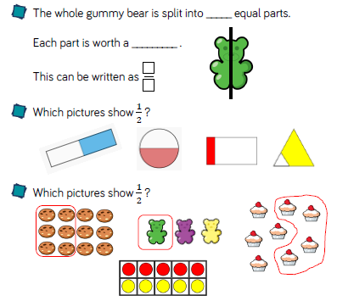  Focus  My Maths – Introducing Fractions  Finding halves of numbers  Find half of amounts using STEM sentences.  Differentiation.  Spiders – Draw 5 different 2d shapes. Draw a line and colour in half of the shape. (Leanne)  Caterpillars – Cut out the shapes and fold them in half. (Lisa)  Worms - Colour half of each shape. (Sian)  (When children have finished task they can they access the challenge areas.)  Maths Challenge – Half it/Share it  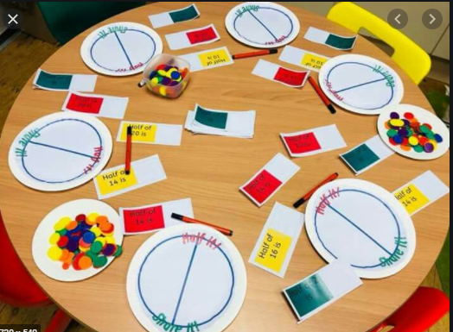  Maths Attack – 10 times table (10 minutes daily)  Thursday - Numeracy – Find a half  Introduction  Find half using hoops, paper plates, containers. Reinforce half is sharing equally between two groups.  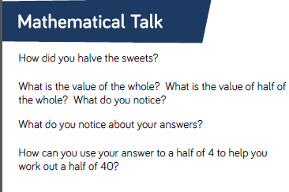  Focus  My Maths – Introducing Fractions  Finding halves of numbers  Find half of amounts using STEM sentences.  Differentiation  Spiders – Find half of numbers to 20 extend by finding halves of tens numbers. (Leanne)  Caterpillars – Circle half of the objects in each picture use numicon to support. (Amounts to 20) (Lisa)  Worms – Share objects between the hoops use numicon to support. (amounts to 10) (Sian)  Friday - Numeracy – Problem Solving – Finding Half  Focus  My Maths – Introducing Fractions  Finding halves of numbers  Find half of amounts using STEM sentences.  Focus  My Maths – Introducing Fractions  Finding halves of numbers  Find half of amounts using STEM sentences.  Differentiation  Spiders – Leanne Caterpillars - Lisa  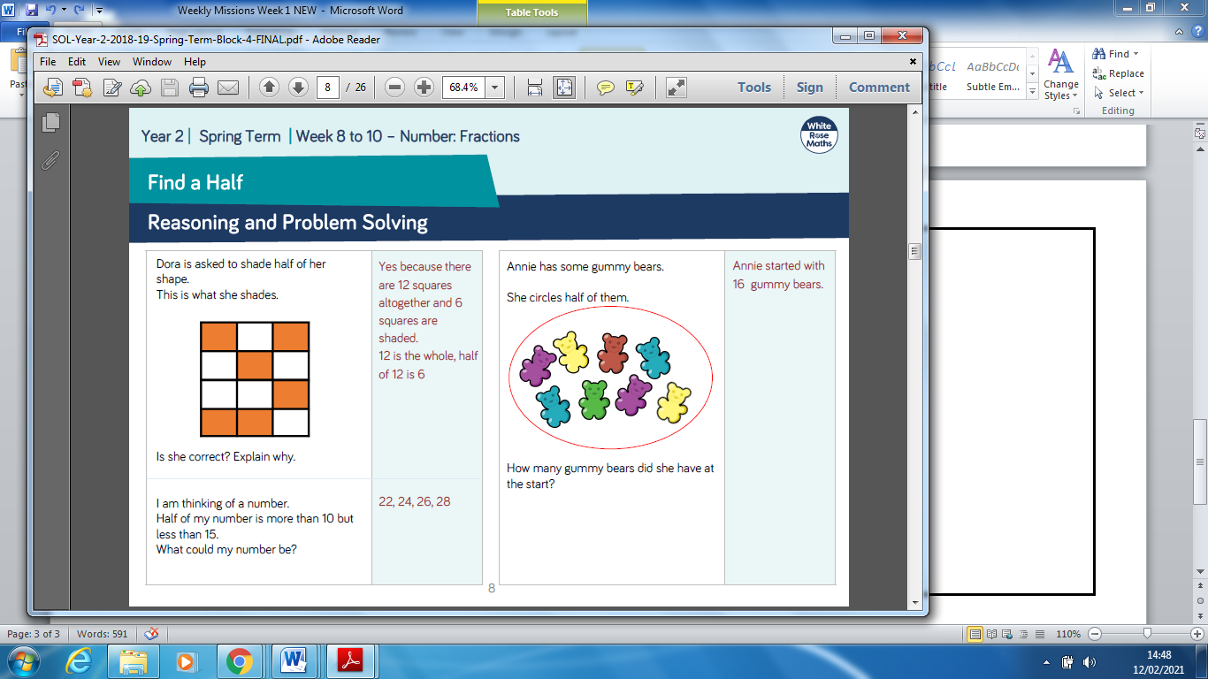  Worms  

