  Date: |  |  |  | Theme: Wriggle and Crawl  Year group: 1/2 PPA - Mrs Watts
Literacy      This Photo by Unknown Author is licensed under CC BY-NC-ND   | Numeracy     | Creative     | Thinking     |  | Healthy me    
 | Mrs Watts Maths Challenge:  Shut the Box  Play this game by clicking on the link: Shut the Box for Two (maths.org)  You can print and use the number card resource for the game.  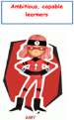 | ​Mrs Watts Art Challenge:  Metalwork Butterflies and Dragonflies  Follow the instructions on the resource sheet to make a shiny butterfly or dragonfly. Use what you have at home to make it.  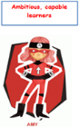  Mrs Watts Music Challenge:  The Minibeasts came in two by two.  Use the backing music resource to sing the song, ’The Minibeasts came in two by two’. Use the flipgrid code: https://flipgrid.com/bf40693e to record your performance and send in.  Have fun!  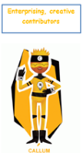 |  |  | PSD: Being resilient  Use the powerpoint, ‘Resilience Bouncing Back’ to find out what resilience is.  Activity: Complete ‘Resilience activity’ resource.  When you have finished listen to:  Bounce Back - the resilience song - YouTube  P.E. lesson  Lick on the link: Year 1/2 PE lesson 5 - YouTube  And follow the lesson.  

