Building a new Bridge for The Three Billy Goats Gruff.
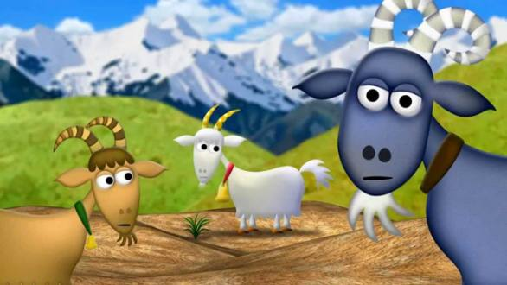

We predicted which materials we thought would make the best bridge.

We looked at castles across the ages.

We sketched our favourite type of castle.

