As shiny as ……………….
As pretty as ………………
As tall as …………………
As dark as …………………
As juicy as ………………..
As busy as ………………..
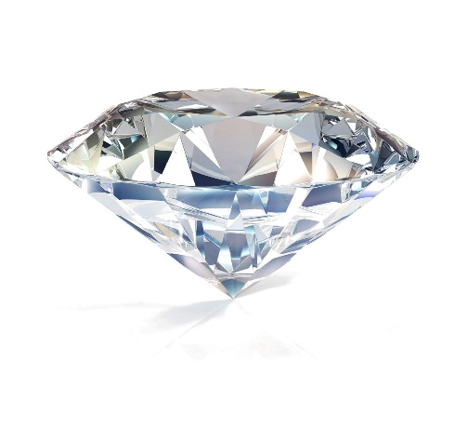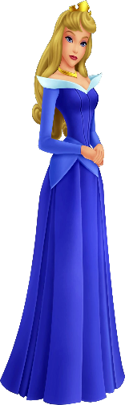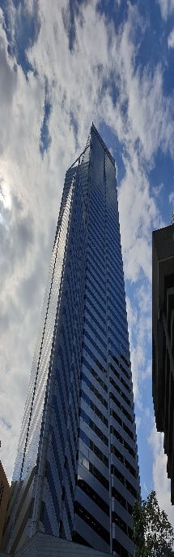
diamond princess skyscraper

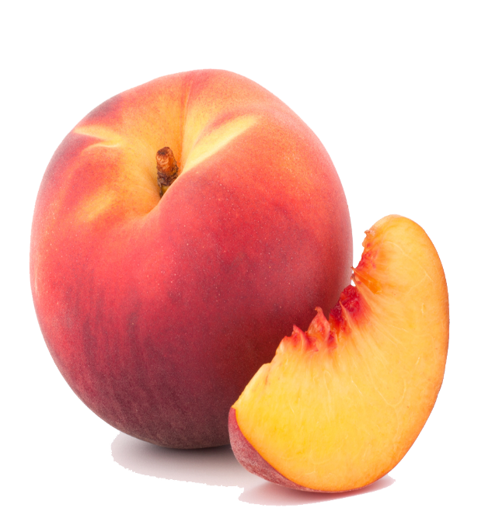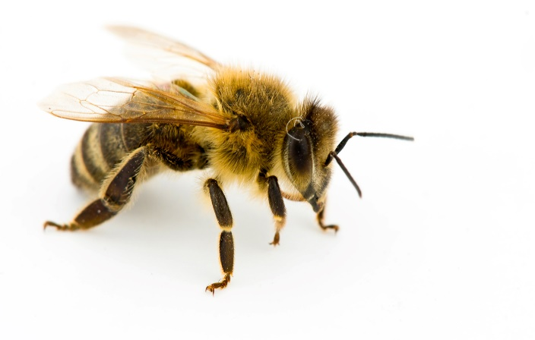
black peach bee

