Thank you for…….
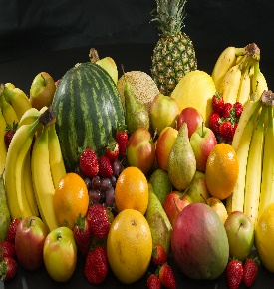 fruit 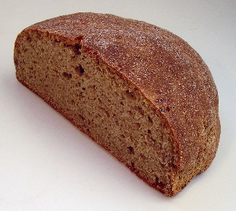 bread 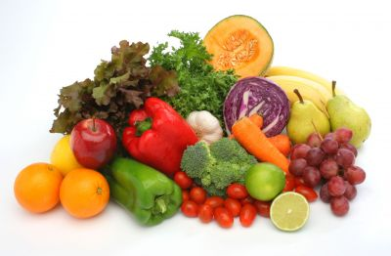vegetables
This Photo by Unknown Author is licensed under CC BY-SA
This Photo by Unknown Author is licensed under CC BY-SA
This Photo by Unknown Author is licensed under CC BY-NC-ND

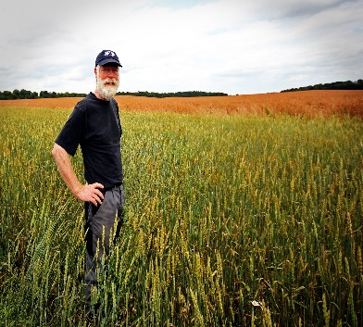 farmer 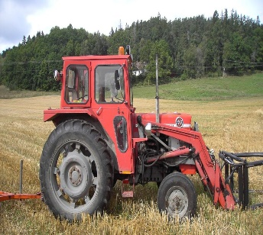tractors 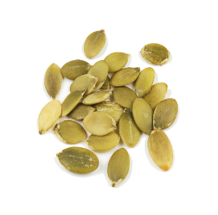seeds
This Photo by Unknown Author is licensed under CC BY-SA
This Photo by Unknown Author is licensed under CC BY-NC

