  Date: 09/11/2020 |  |  |  | Theme: Do Cows Drink Milk?  Year group: STF1
Literacy      This Photo by Unknown Author is licensed under CC BY-NC-ND   | Numeracy     | Creative     | Thinking     |  | Healthy me    
RWI Monday - Thursday – The sound of the week is g. We will be listening and singing along to our two favourite sound songs - https://www.youtube.com/watch?v=ru0KCAS5zuY and https://www.youtube.com/watch?v=dyeqR9NHZFU We will be looking at picture cards - saying what they are and Fred talking sounds to work out the words that have the sound of the week in. We will be learning to read words that start with g and having a go at writing these down. Level 1 – forming the letter in a range of multisensory ways. Level 2 – writing words that has the letter in it.  Wednesday - Spelling – The children will be tested on their spelling words. The children will listen to the word and have a go writing. Any words that are not correct the children will have another practise by writing the word three times.  Readers – Children will read to an adult on Tuesdays and Fridays.  Monday - News – Children will be sharing their news with their class from the weekend. Level 1 – An adult will prompt the child, either by showing pictures that parents have sent in from the weekend on classdojo or by signing/using key words eg park? Beach? Children will then be recording their news with an adult – either by mark making and drawing picture (an adult will then scribe to say what they have written about) or Level 2 - children will be writing sentences and drawing a picture.  Thursday - Text type – This term out text type is recount. This week we will be looking at our recount pack which includes a description of what a recount is, words that we may use in a recounts eg time connectives and a good example to start. We will then show the children pictures of an activity we did this week and the children will sequence the pictures and talk about them using time connectives as a class. (level 1) sequencing pictures to show beginning, middle and end of the activity. Encourage children to use time word – first. (level 2) the children are progressing on to talking about the activity/pictures using full sentences including time words.  IEP target – an adult will work with a child on a 1-1 basis so they can have an opportunity to practise their literacy IEP target.  Welsh – recap previous week’s words/phrases of the week – ‘croeso,’ ‘hwyl. Gela y fori.’ Penblawdd hapus. All repeat the word, look at the spelling and read the word, copy write the word. Say the word to a friend, say it to an adult. Introduce this week’s word/phrase of the week. Practise reading, saying and practise copy writing. Ask and answer with a friend.  Recap topic words learnt so far for the animals of the week – buwch, mochyn, dafad, cwy iar, gafr, ci and cefyl. Teach this week’s animal hwyaden – . Children to draw/stamp/stencil around the duck and overwrite (level 1) or copy write (level 2) the word. | Monday and Wednesday Level 2 - Number of the week – This week the number of the week is – 2. We will read the story of 2 - http://resources.hwb.wales.gov.uk/VTC/story_of_2/eng/Introduction/default.htm We will practise forming 2 in multisensory ways – in paint, in glitter, on chalk boards etc. We will use resources to count 2 and to show 2 objects.  Monday and Wednesday - Level 2 – Introduce the concept ‘1 more than’ to the children. Show the children - https://www.youtube.com/watch?v=Du6JHupzwVo We will put the plastic toy fruit on the carpet with plastic bowls and the children can work out the answers. For example the teacher will say ‘what is 1 more than 7?’ The children will have 7 pieces of fruit in the bowl and say ‘1 more’ while adding 1 more in and counting to find the answer. To remind the children of the number in their bowl we will display a number chart on the IWB - https://www.topmarks.co.uk/learning-to-count/paint-the-squares The children can ‘splat’ the number that the teacher has said and can ‘jump’ to the right to work out 1 more than.  The children will then complete 1 more than sums in their books.  Carried over - Tuesday - Shape, space and measure lesson – Level 1 - Recognise and use the names of common 2D shapes (square, triangle, rectangle) and 3D shapes (cube, cuboid) in order to begin to compare and sort them  Shape introduction and activities can be found on -  https://app.mymaths.co.uk/myportal/library/16/171#collapse2  We enjoy these two shape songs - https://www.youtube.com/watch?v=pfRuLS-Vnjs and https://www.youtube.com/watch?v=WTeqUejf3D0&index=24&list=PLBCINYK5ChNptVR2-BgGmWoBKliLIOBN-  Level 1 – The children will focus on one shape a week until they become more confident identify/matching/saying the shape. This week the children will focus on circle. The children will draw around the shape with an adult and overwrite the word. The children will be asked to match the shape/find the shape/name the shape. As an extra activity the children will create a 2d shape picture each week linked to our topic – farm animals. The adult working with the children will focus on the shape of the week and remind the child of the name of the shape while cutting out ‘a circle.’ This week we will make the sheep.  Level 2 – We will go through the shape introduction on mymaths for circle - https://app.mymaths.co.uk/myportal/library/16/171#collapse2 The children will then create a 2d shape farm animal picture – the sheep this week. The children will carefully cut out each shape, arrange and stick together to create. The children will label using the shape name.  On Thursdays we use the digital devices to develop our maths skills as well as digital skills. Children will be using ipads/beebots/computers and interactive whiteboards to play a range of games on Topmarks to consolidate their learning for the week in the number lessons eg this week we looked at 1 more than and shape.  IEP target – an adult will work with a child on a 1-1 basis to develop their numeracy IEP targets. | Each week we are going to focus on drawing/creating the animal of the week. We will do this by either working as a team to create one large animal or working by ourselves to create our own. Each week we will change the resources/materials, for example, one week we will draw, another week we will paint, the next week we may decide to create a craft piece of work. The children will help decide each week the materials we are going to use. Last week’s animal of the week was horse so we will be focussing on that animal this week in our art work.  Level 1 – We will print out and enlarge the animal of the week. So that the children can look at it closely with an adult. The children can help choose the resources they use after being given a selection of materials. The child will work with an adult to create the artwork. These children can also practise drawing around stencils if they wish or printing.  Level 2 – The children will help find the animal on a search engine. The children will look at the features of the animal, the colours, how many legs etc, special features and plan their drawings. The children will choose their tools/materials. An adult will help improve the artwork by the use of questioning.  Music – we follow the music scheme online called Charanga. Each week we listen to one song while dancing and deciding if we like it. We then answer questions such as was it fast or slow? What instruments did you hear? We then listen to songs to find the beat/pulse and find it in different ways eg tapping, clapping, nodding, clicking. We then learn the song and sing the song. After all of the Charanga songs have been sung each week we will choose a farm animal song to sing – baa baa black sheep, a farmers in the den, five little ducks, horsey horsey don’t you stop etc. If you would like to sing at home with your child there are a range of nursery rhymes on Youtube to sing along to. | Ask the children what our new topic is? Do cows drink milk? Ask the children what they remember from our topic introduction? Remind the children of the videos that we watched. Show the children some of the ‘what I know/what I want to know’ grids. Tell the children that some of the children wanted to find out about different farm animals so each week we will be looking at a different animal. We will be researching what the animal looks like, what sound it makes, how it moves, what colour it is/can be, what food it eats, where it lives etc and we will be sharing a story about the animal.  This week we will be looking at ducks. We will research information on ducks by viewing a range of videos such as - https://www.youtube.com/watch?v=KESOibZQlhA, http://kiddopedia.net/duck-facts-kids-information-ducks/ and https://www.youtube.com/watch?v=ndiVL4plQDI  The children will be making a fact file of the animal of the week listening - its name, labelling diagrams, writing what they eat, any produce they make, baby names and any other information they can remember.  We will all be engaging in a shared piece of art for our display to show that we have learnt about that animal.  We will be sharing story books about ducks such as – The ugly duckling - https://www.youtube.com/watch?v=TyrmcD8Yml0  For this week’s sensory tray we are going to make farm animal cone shaped animals that we have looked at so far – cow, sheep, pig, goat, dog etc. We also have animal name and sounds cards to match with Welsh animal cards.  Level 1 – Children will sign/point to/name animal of the week. The children will over write/mark make to write the name and draw a picture of the animal.  Level 2 – Children will name, say the noise, draw a picture and write key words/sentences to record the information that they have found out about the animal.  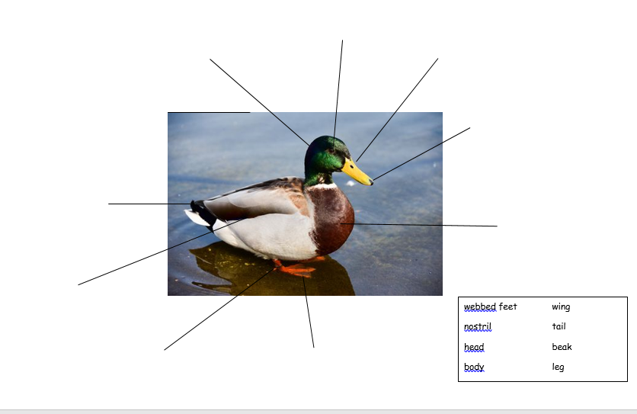  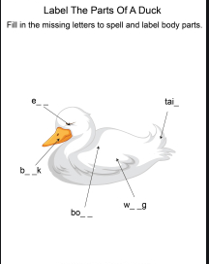   |  | Playdough disco – before writing activities children will be warming up their hands and fingers by taking part in playdough disco (with their own individual pots of labelled playdough).  PD Wednesday – children will be using the bikes, cars and scooters on the yard to develop their skills.  PE Thursday - This week the animal of the week for the topic was the goat. We will watch a video to see how goats move and will try to act this out. Each week we will add to the animal movements. An adult will call animal’s names out and the children will move in that way.  The farmer’s den! Sing the action song The Farmer’s in his Den. Ask the children to make a circle and hold hands. Choose a ‘farmer’ to stand in the middle of the circle then ask the circle of children to walk around the farmer as they sing the first verse of the song. Then, ask the children to stop, and allow the farmer to choose a husband or wife. The song and actions continue until the farmer has chosen a husband or wife, a child, a nurse, a dog and finally a bone. At the end of the song, everyone gathers round and sings the last line as they gently pat the child who was chosen to be the bone.  Sheep dog – the children enjoyed seeing the sheep dog videos from our Cornerstone introduction. We decided that we would create a game where one child one be the sheep dog and the other children will be the sheep. The children will take it in turns to be the sheep dog/sheep. The children will use the vocabulary said in the video to round the sheep up.  Farm animal relay races – The children will decide which animals we have looked at so far are included in the relay races – chicken, sheep, cow, goats etc. Split the class into two groups, one child from each group starts moving as the animal and making the animal noises. They then high five their friend when they get to the other side and their friend moves like the animal.  Joe Wicks is back! You can subscribe to his channel to keep up to date with his new videos.  If you would like to try something different we enjoy Cosmic Kids yoga in class found on Youtube.

