
This Photo by Unknown Author is licensed under CC BY-SA
This Photo by Unknown Author is licensed under CC BY-SA

Sion Corn Anrheg Coeden Nadolig

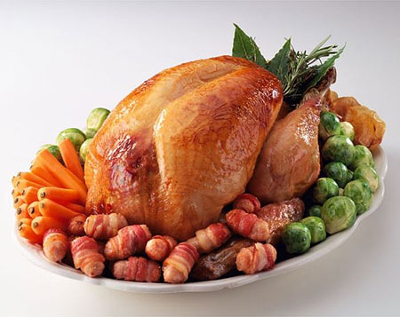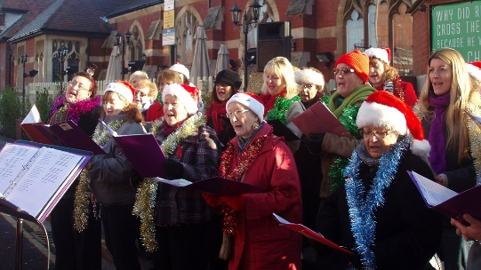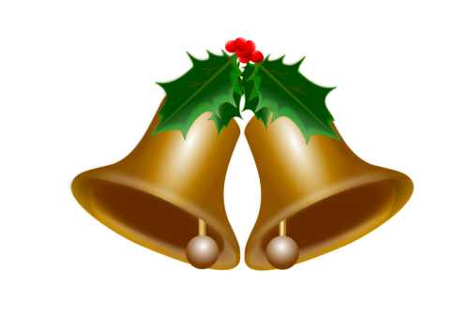

This Photo by Unknown Author is licensed under CC BY-ND
This Photo by Unknown Author is licensed under CC BY-SA
Twrci Canu Gloch


