How many ways can you make 10p?
Extra Challenge: How many ways can you make 20p?
Practice your number formation.

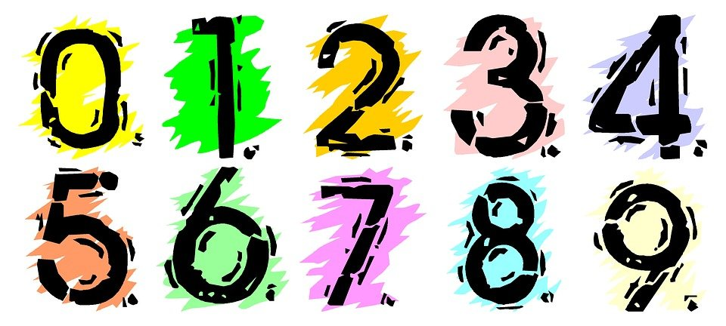

Practice your letter
formation.


