Word Bank
clock tower 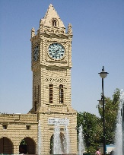 colourful 
This Photo by Unknown Author is licensed under CC BY-SA
girl town 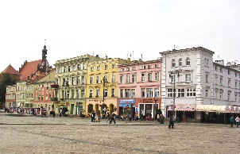 houses 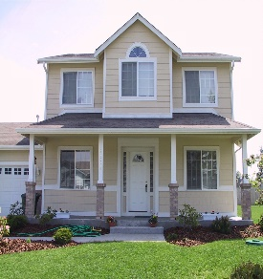
This Photo by Unknown Author is licensed under CC BY-NC
This Photo by Unknown Author is licensed under CC BY-SA
This Photo by Unknown Author is licensed under CC BY-ND

Word Bank
clock tower colourful
This Photo by Unknown Author is licensed under CC BY-SA
girl town houses
This Photo by Unknown Author is licensed under CC BY-NC
This Photo by Unknown Author is licensed under CC BY-SA
This Photo by Unknown Author is licensed under CC BY-ND

